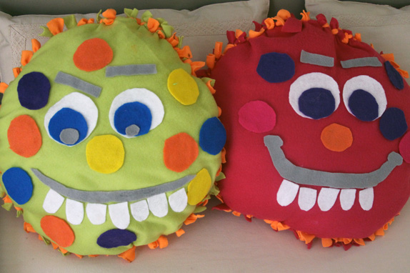

MONSTER PILLOWS

- Choose two pieces of large round pre cut fleece with tabs.
- Pin them together.
- Tie the tabs of the front piece of fleece to tabs of the back using a double knot.
- When you are mostly done take the plain pillow and stuff it inside the fleece.
- Continue tying the rest of the fleece tabs together.
- Make sure you take out the pins.
- Take the smaller fleece shapes and glue them onto one side making a monster face. Feel free to cut your own shapes.
- Let dry.

Additional resources:
How to tie the knots: https://www.youtube.com/watch?v=87qwwsfRBa8

